User Manual

Data Structures

Final Project - 30 de noviembre de 2016



Daniel Charua A01017419

Isaac Halabe A01021800

Introduction

The program CheapestHighway in its graphical mode it is easy to use. The program, were it can be added cities as points and highways between the cities with different tolls each, also calculate the cheapest way from one city to another. It uses the algorithm Djikstra to calculate the cheapest path, and using the SMFL library it draws the path.

The program also let the user consult the cost of any of the highways, and some important option for searching cities using the methods ‘Breadth and Depth’ were it prints all the cities in different ways each one and let the user search for something specific.

The algorithm basically checks the cheapest way from the starting point to all the others, it calculates the route from the origin to one point and then if the program can get to the same point by other path and is cheaper, it changes to the default way to that point, and it makes that path until the program arrives to the final point.

To Start

For using the program, the user must have SFML Libraries installed already in the CPU. The user will use the program by typing on terminal ‘make’ to compile the program, than the user must type on the terminal ‘./main’ to run the program.

Menu

At the start of the program it will display a menu:

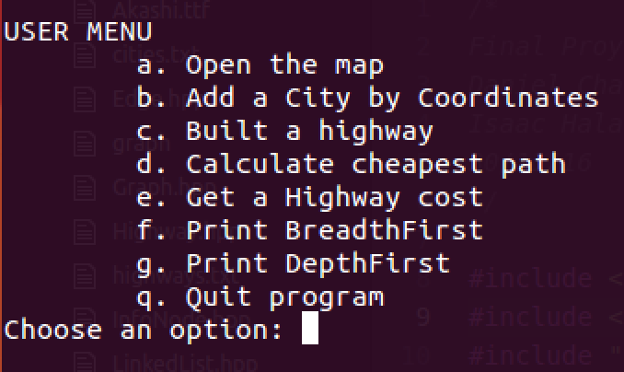

There are 7 different options plus the ‘Quit’ option.

a. Open the map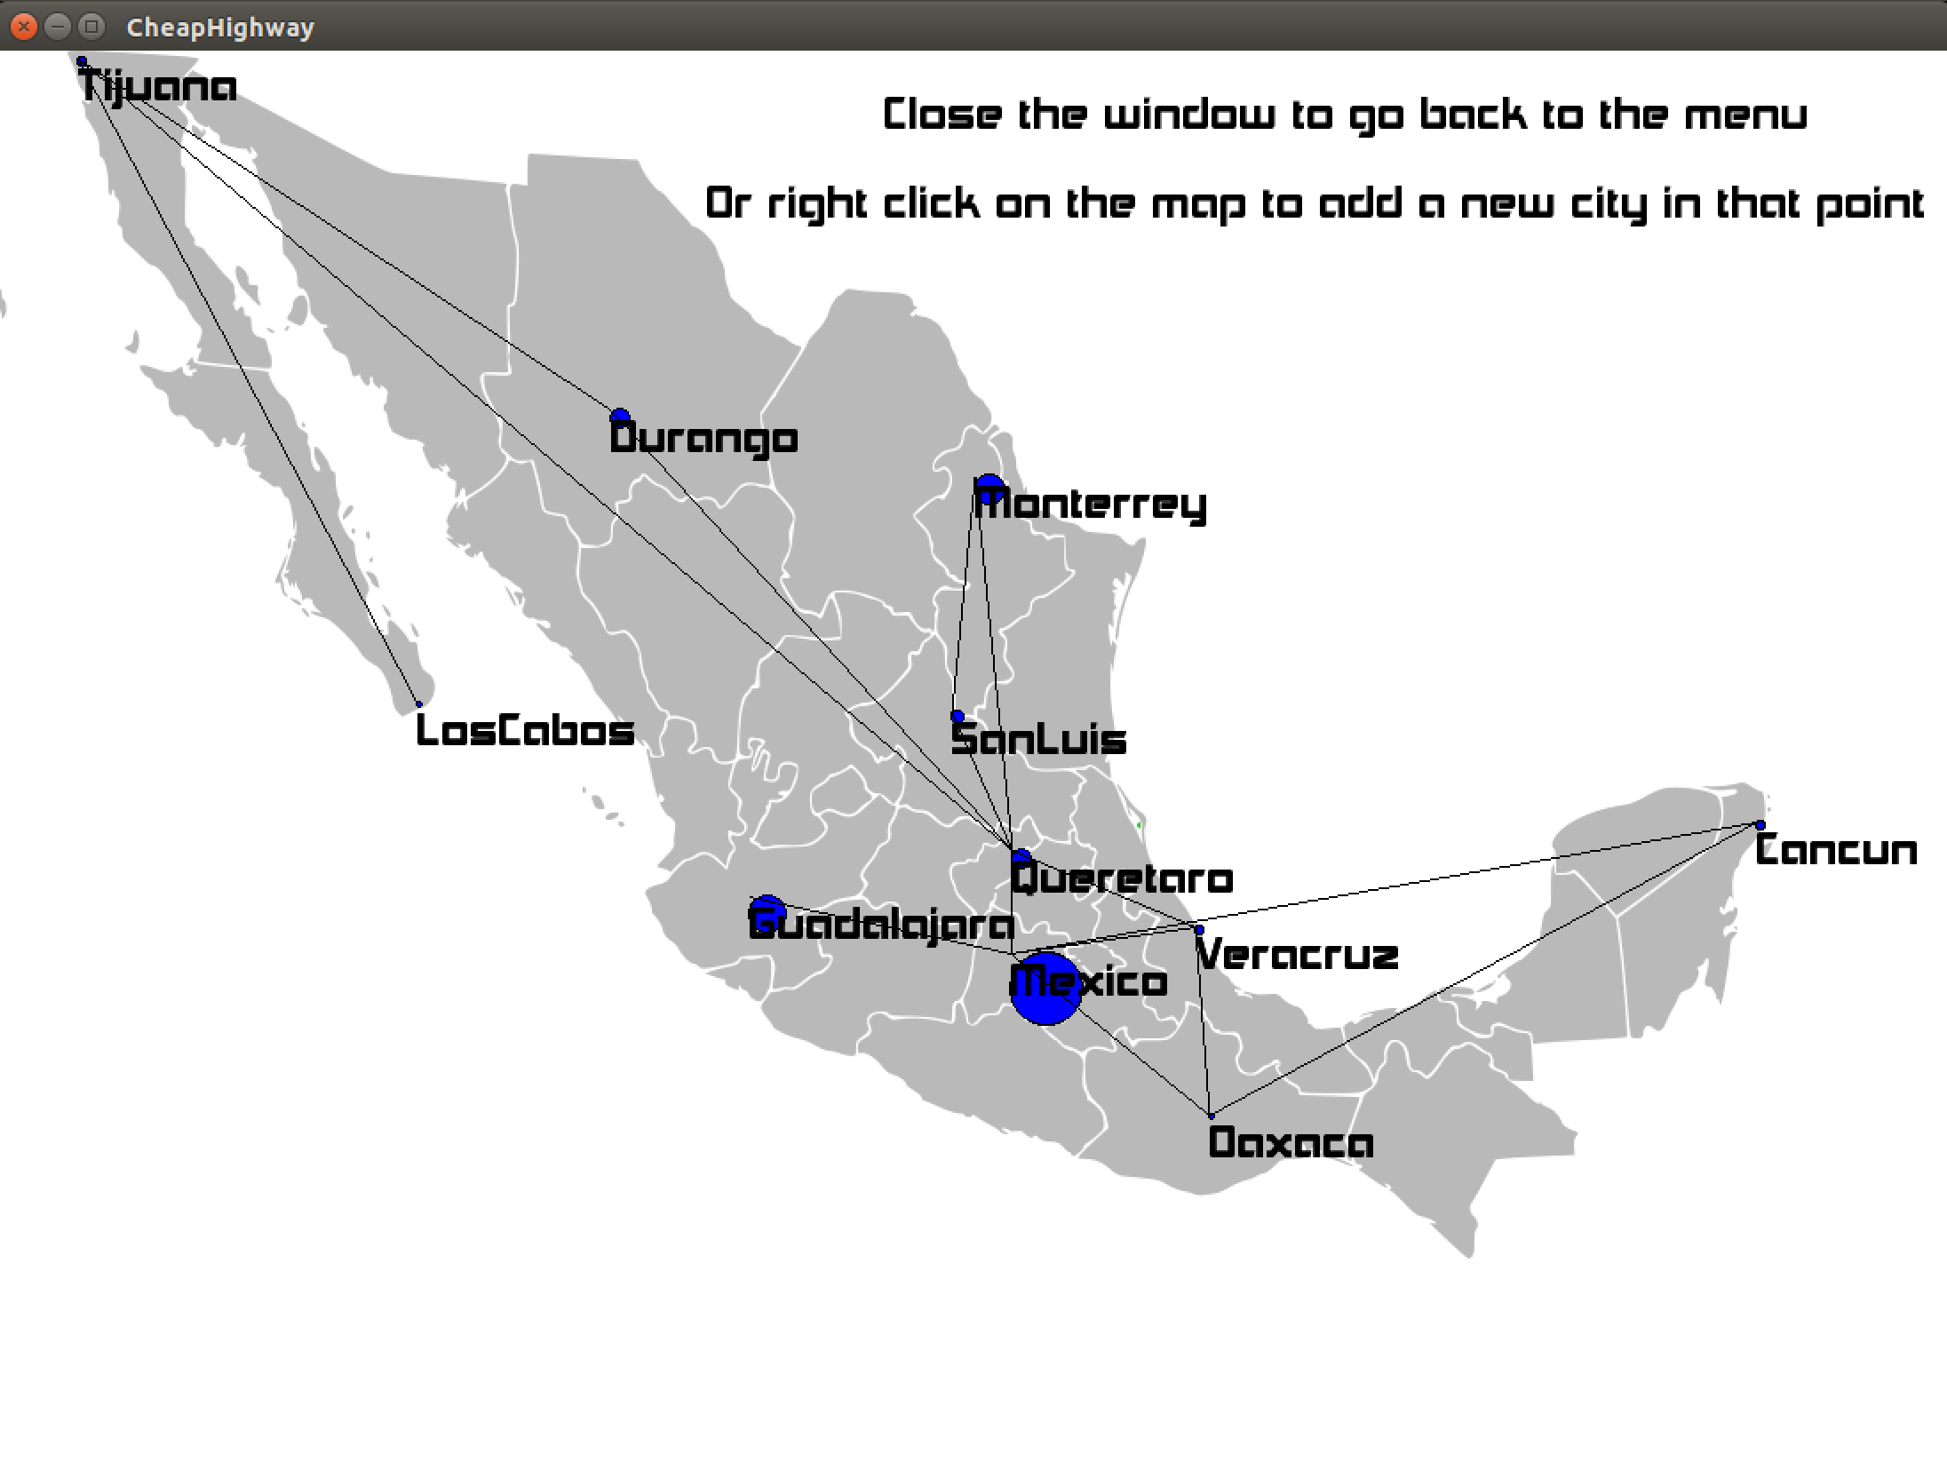

This option will display graphical map of Mexico with the cities and highways that the user has set. There’s the option to add a city by clicking on the map with the right click, then set the values on the terminal. To get back to the menu, the map must be close.

b. Add a City by Coordinates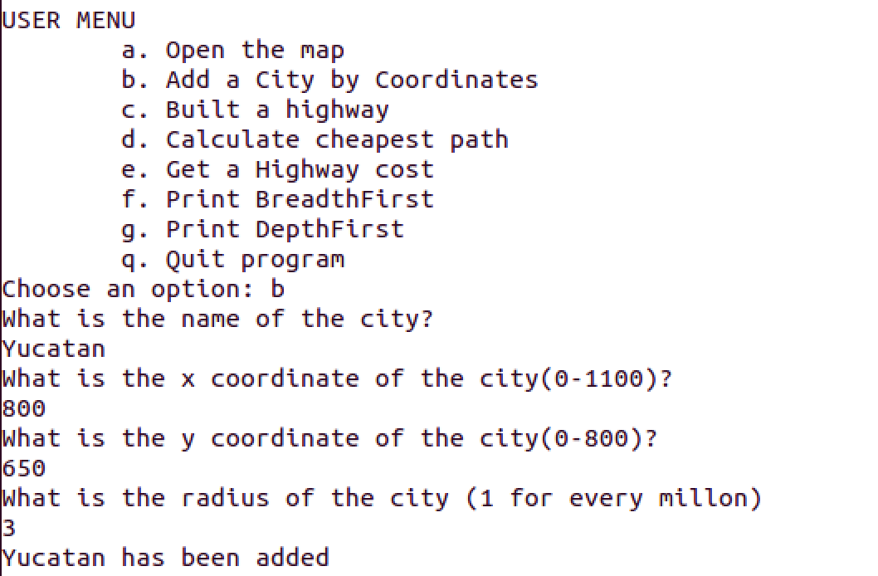

Entering to this option the user will be able to add a city by entering coordinates on the ‘X’ and ‘Y’ axis, then the user must enter the correct values for each city.

c. Built a Highway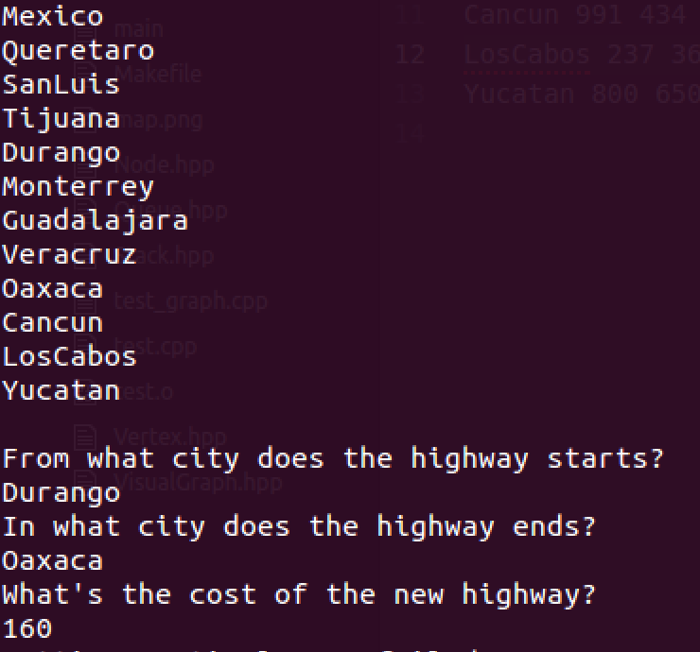

After adding some cities to the map, with this options the user can add highways between cities with a toll. The user must enter a starting and ending point and the toll. The program helps the user by displaying all the cities available.

d. Calculate Cheapest Path

One of the most important option of the program is this, were the user can find the cheapest and shortest path from one point to another. The user must type a starting and ending point. The program first will display the map with the selected points and the route. If the map is close the user is able to see the complete path and the total toll.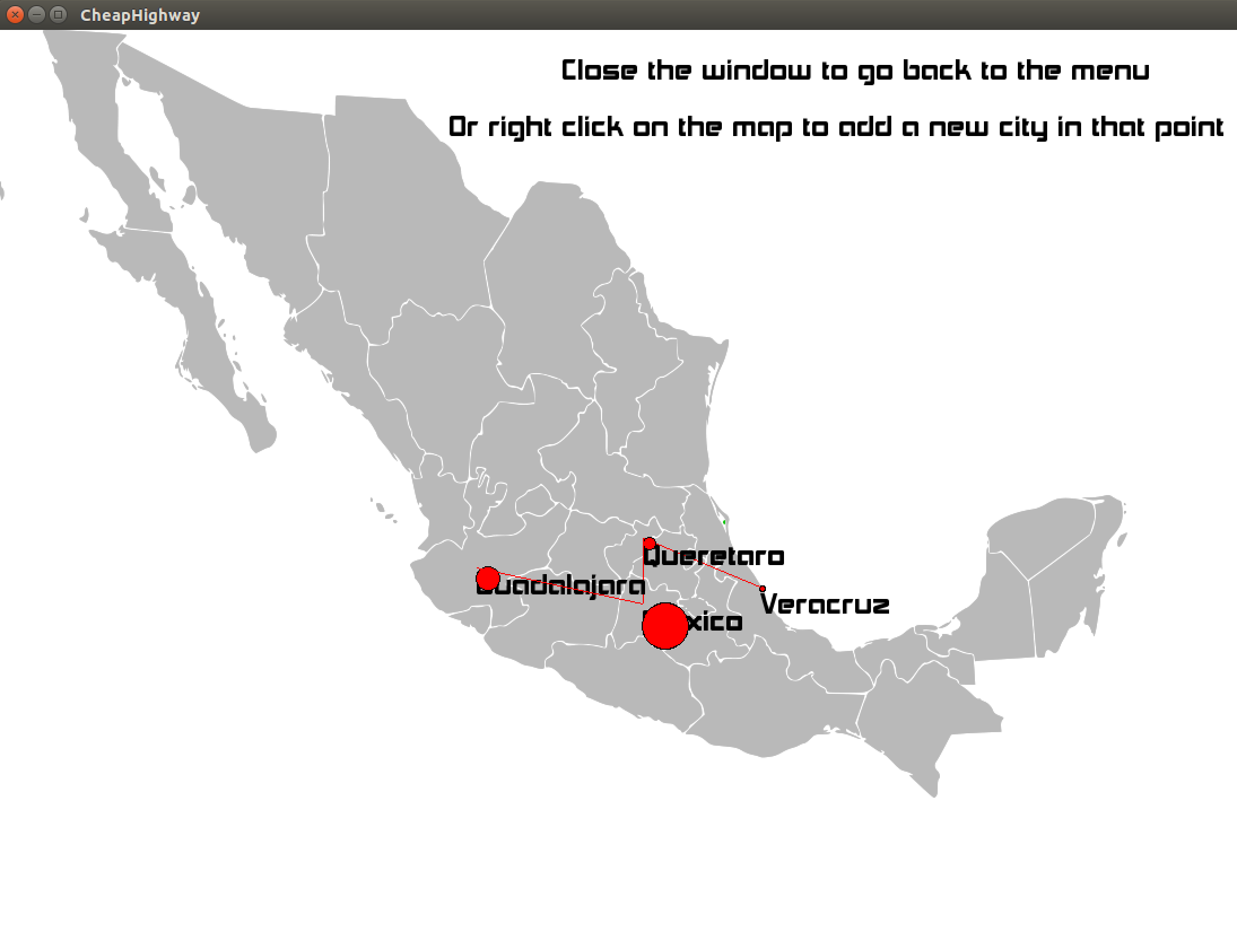

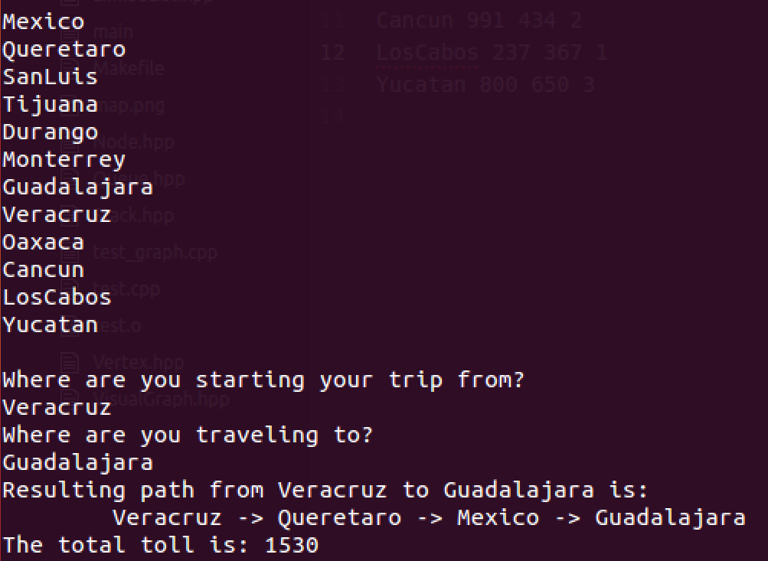

e. Get a Highway cost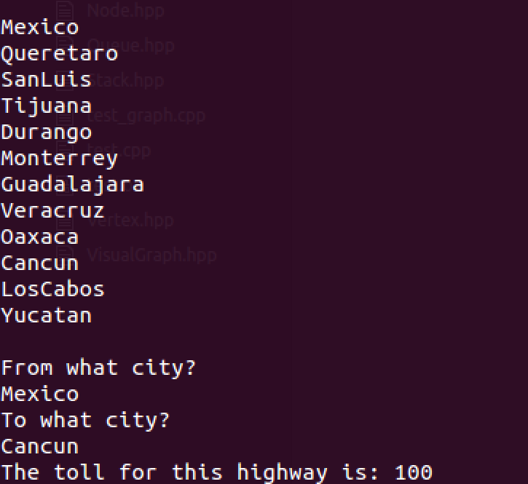

The user also can search for the cost of any highway.

f. Print Breadth First & g. Print Depth First

By this 2 options the user can print all the cities added on the map in this two different ways.

q. Quit Program

To exit the program, the user must type ‘q’.